File Changes

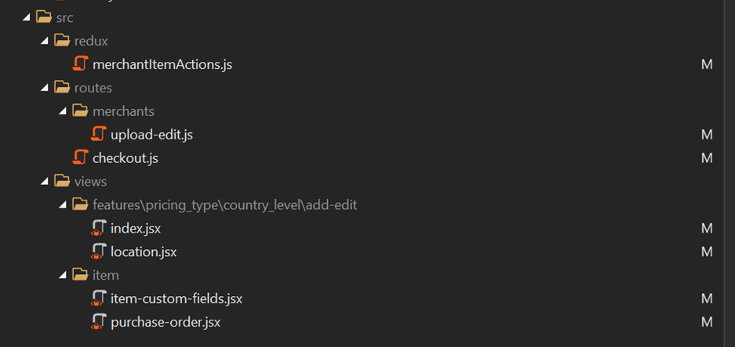

File Description

merchantItemActions.js

line 1223 and below

Using the details of the main item weight code. We use it to save at the childitems as custom field also.

Upload-edit.js

Line 1166 and below

We are assigning the values from the custom field to our model before sending to view.

Checkout.js

Line 1713 and below

We are checking if the buyer had selected a child item.. if does we are checking the weight and assigning it to the array.

Index.jsx

No changes

location.jsx

line 194 and below

we are adding the textbox placeholder of the weight

item-custom-field.jsx

line 24

we are assigning an attribute for that element so that we can fetch using the code

purchase-order.jsx

line 491 and below

We are fetching the weight base on the user selection at the dropdown. We are then replacing the weight values using the changes we did at item-custom-field.jsx

Variant Level



Pricing-stock.jsx

Line 213 and below

Added textbox for the input of weight